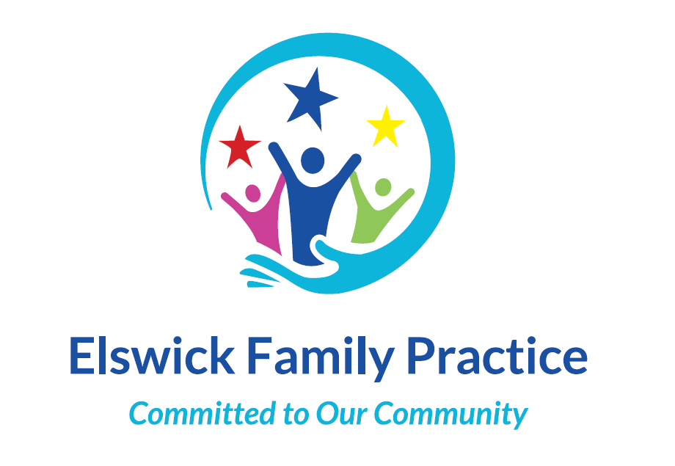

|  |  |
| --- | --- |
| Monday | 08:00am – 18:00pm |
| Tuesday | **08:00am – 18:00pm** |
| Wednesday | **08:00am – 18:00pm**  **We are closed 12pm-1pm** |
| Thursday | **07:00am – 18:00pm** |
| Friday | **08:00am – 18:00pm** |
| Saturday | **9:00am – 13:00pm** |
| Sunday | **Closed** |

#### Patient Participation Group

We hold regular meetings here at the surgery with our patients who are members of the PPG to discuss aspects of the surgery both negative and positive and to improve the service we provide.

We are actively looking for patients to join our patient participation group. The group meets four times a year with staff members to discuss Practice matters and input from group members is greatly appreciated.

We welcome all patients and carers and if you need any support to attend these meetings such as interpreters please let us know and we will help any way we can if you would like to be involved.

If you would be interested in joining the Patient Participation group please leave your details with reception and the staff member involved will contact you to give you further information.

You can also visit our website at [www.elswickfamilypractice.nhs.uk](http://www.elswickfamilypractice.nhs.uk) for more information.

Tel: 01912986060

Email:elswickfamily.practice@nhs.net

Elswick Family Practice

Meldon Street

Elswick

Newcastle upon Tyne

NE4 6SH

Website:

[www.ElswickFamilyPractice.nhs.uk](http://www.ElswickFamilyPractice.nhs.uk)

Facebook: Elswick Family Practice

Twitter: @ElswickFamily

Welcome to Elswick Family Practice

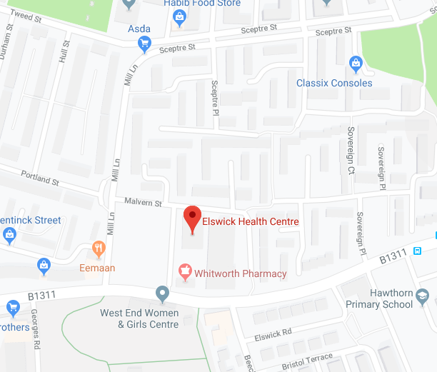

### Opening Times

We also have attached staff working from the surgery including Health Visitors, Midwives, Counsellors, Social Prescribers and both child and adult Mental Health Workers.

#### Clinics and Services

**Diabetic Clinic**

This clinic will deal with your annual reviews or any problems you may be having with your diabetes.

**Minor Surgery**

Minor Surgery is now offered to patients here at the surgery. Some of the procedures we offer include, skin tags removals and steroid injections. For further information please ask a member of staff.

**Some other Services offered at the surgery include:**

**Cervical Smears**

**Flu Vaccinations**

**NHS Health Checks**

**ECG’s**

**Taxi Medicals**

**GP letters**

**Contraception**

**Physiotherapy**

**Palliative Care Support**

#### eConsult

Want advice from your doctor, self-help information or have an administrative request (such as a sick note or test results)?

Use eConsult via our website and get a response before the end of the next working day or sooner.

[www.ElswickFamilyPractice.nhs.uk](http://www.ElswickFamilyPractice.nhs.uk)



#### Have you heard about our online services?

GP online services allow you to access a range of services via your computer, mobile or tablet. Once you have signed up, you will be able to:

* book or cancel appointments online
* renew or order repeat prescriptions online
* view parts of your GP record, including information about medication, allergies, vaccinations, previous illnesses and test results
* Make suggestions and give feedback on the surgery through our regular questionnaires

**And much more!**

You can still contact the practice by phone or in person, this is just another option which other patients have found is more convenient and saves them time.

If you are interested in registering or want more information about this service please contact the surgery.



Practice Manager

Tracey Carr

Operations Manager

Louise Reed

Developmental Lead

Kelsey Fradgley

Secretary

Julie Stafford

Reception Supervisor

Diane Carr

Receptionists

Anthony Kirby

Krystyna Tchorz

Lauren Fradgley

Jessica Davies

Leah Pearson

Simone Fosher

Jules Penridge

Doctors

Dr Antony Moore

Dr Nasreen Mowla

Dr Gill Rowlands

Dr Forood Ranaie

Dr Prasanna Ponna

Nurse Practitioners

Mark Dillon

Practice Nurses

Laney Fitzpatrick

Health Care Assistants

Lynsey Anderson

Jennifer McConville

### Meet the Staff